**Writeup Task**

* This slide is about the JavaScript error handling.
* The aim of the slide is to code assuming that we will make errors so that it will be easy to find the errors before it makes a bigger consequence.
* There are totally 7 rules explained in this SlideShare presentation
* RULE 1: Assume your code will fail
  + When we write a code, we should always assume where will the error happen and try to figure out the problem as mentioned in slide 8.

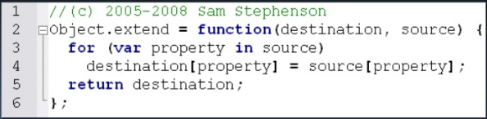

In the above-mentioned program let’s assume what if the destination and source is null.

* RULE 2: Log errors to the server
* RULE3: you, not the browser handle the errors
* We have to use try and catch error handling

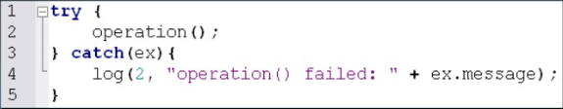

* Errors that are thrown contains extra information and the errors that are thrown in the catch part are already handled.

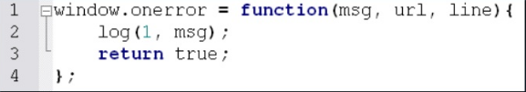

* Window.onerror – supported only in IE and Fire fox.
* RULE 4: we should assume where the errors will occur
* There are different types of errors happening
* Main thing is the communication errors.
* The main cause of communication error is that invalid URL/Post data, Server response status
* No network connection
* Server response content
* RULE 5: Throw your own errors

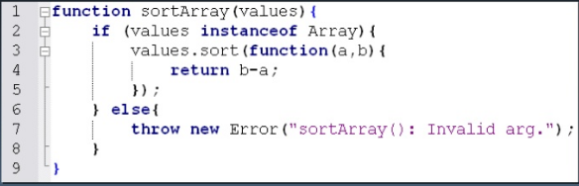

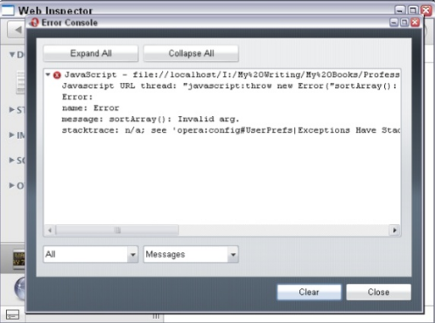

* Errors should be thrown only at low level to avoid large consequences
* Have to enhance the debugging by using try catch.
* RULE 6: Distinguish between fatal and non fatal errors
* Non fatal errors will not interfere in the main task and will be easy for recovery.
* Fatal errors on the other hand will not allow the application to continue.

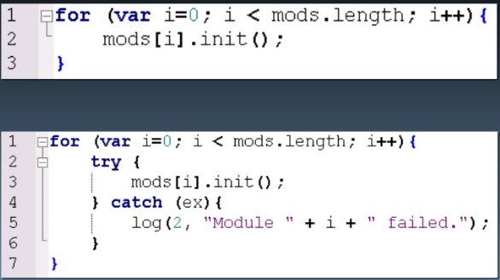

RULE 7: provide a debug mode.

Try catch should re-throw an error.

Window.onerror should return false.

